
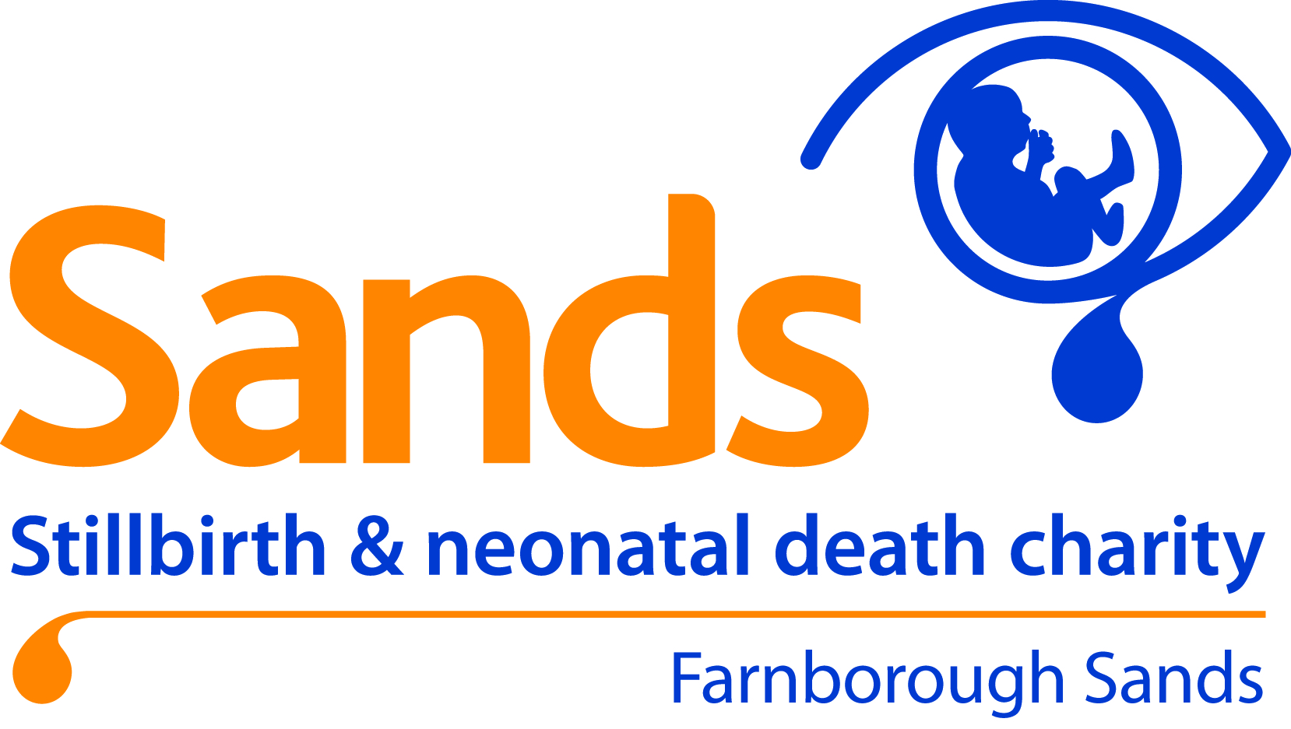

Farnborough Sands Baby & Children’s Memorial Garden - Engraved Pebble Order Form
See pricing table on page 2

NAME:
ADDRESS:

TELEPHONE NO.
EMAIL ADDRESS:

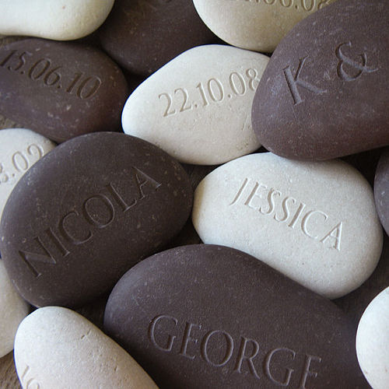 | Please write the Name and/or Date you would like to appear on your pebble below and if you would like an icon please indicate which one (Please see table on page 2 for pricing details and available icons)
GREY PEBBLE
- warm plum-grey hues
- length ranges from 10-15cm
- These larger grey pebbles can include up to 3 lines of text (12 characters per line).
Delivery Address
Please advise if this is different to the
Address you have given above

TO ORDER
Please make payment either online or send a cheque (see details below)
AND email or post your form to memorialgarden@farnboroughsands.co.uk

PAYMENT DETAILS – See table for Pricing
Online transfer: Bank: Lloyds, Sort Code: 30-90-69 Account No. 36493368. Please label your payment with a reference ‘PBL plus your surname’ (e.g PBL SMITH) so we can track payments
Cheque: Please make payable to ‘Sands Farnborough’ and write PBL and your Surname on the back of the cheque (e.g PBL SMITH). Post to Farnborough Sands Engraved Pebbles, c/o Philippa Owen 7 Shetland Way, Fleet, Hampshire, GU51 2UD.

Important Info - Please note
- Dates are converted to numbers eg: 15th August 2011 will be 15.08.11
- "Characters" are letters, spaces and punctuation eg: M.J.0 & F.S.0 is 13 characters and too long!
- All letters are engraved as CAPITALS
- There will be variations in colour, markings and shape as this is a natural stone product
- The pebbles are not man-made. They are natural stones smoothed flat on river beds and may contain imperfections e.g. chips, fissures and cracks, mottling, colour blemishes and fine grey thread lines (the white shows up more flaws than the grey and come in a range of shapes). Stones will vary in size, shade, shape and texture; if you order two stones they will not match. We have taken a rough, organic product and left it in its natural state, engraving the type like a stamp in the stone. We hope you'll appreciate the uniqueness of these natural stones, and treasure them as a personalised keepsake.
- You can have your pebble delivered to you at home or collect it from the Bereavement Services Office on site – please call ahead to check it is there before visiting
- Pebbles can be laid during the normal crematorium opening times (see website)
- To maintain pebbles and the area where they are laid, staff will carry out an annual cleaning operation so your pebble may be moved position within the moon shaped bed but will always remain in this area of the garden
- We will advise how long it will take to receive your pebble but please allow 2-3 weeks on average.

Item | Price (including standard delivery)
Engraved Message 1 Line | £18.40
Engraved Message 2 Lines | £22.60
Engraved Message 3 Lines | £26.80
Engraved Message 1 Line + Icon | £20.40
Engraved Message 2 Lines + Icon | £24.60
Engraved Message 3 Lines + Icon | £28.80

Icons
- Gold Heart
- Silver Heart
- Gold Star
- Silver Star
